CONCRETE STRENGTH PREDICTION

WIREFRAME DOCUMENT

Balamurali K iNeuron

Homepage

Homepage consists of single page having different section to go on. The page designed in such way that user can switch between Home page, Logs ,Profile Report, Model Experiment Results and Estimate Concrete Strength. There are 4 different sections in the homepage where the user can switch according to requirement.

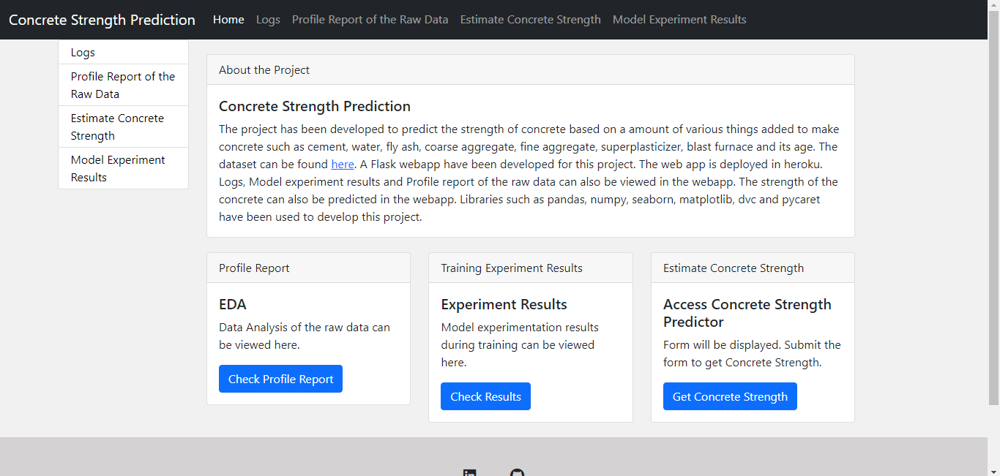

Estimate Concrete Strength Prediction form:

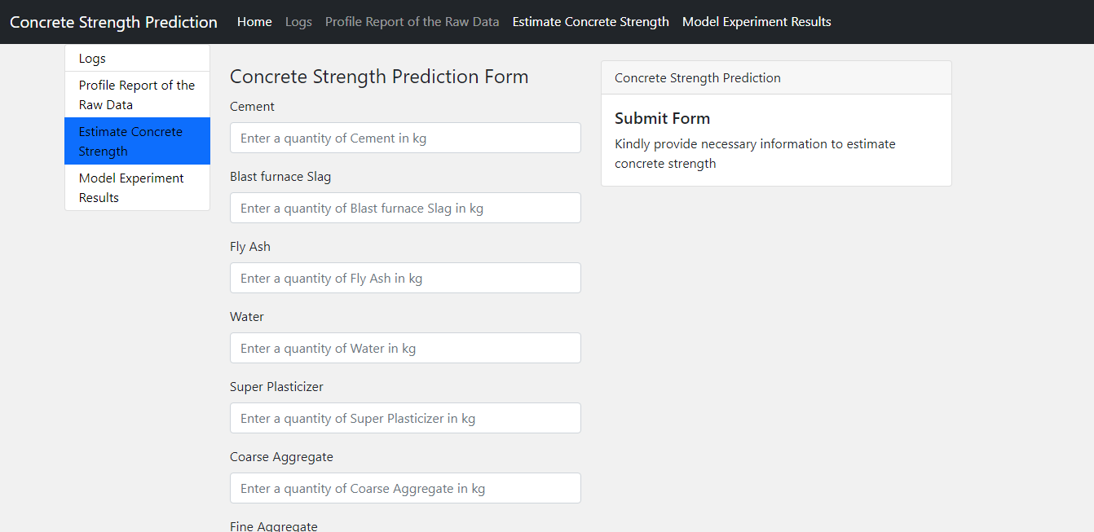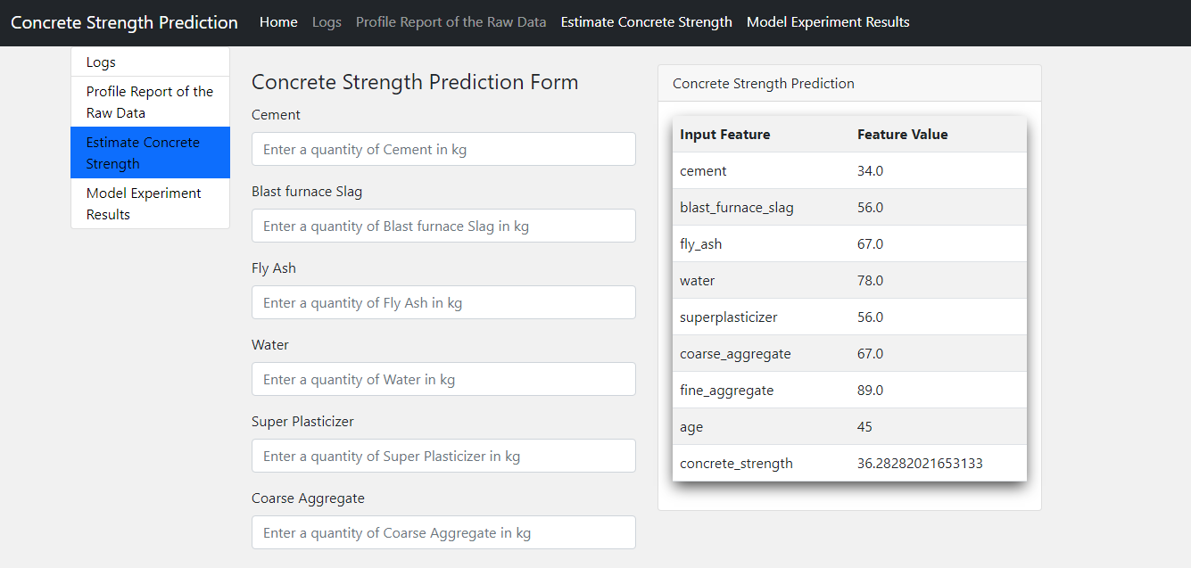

Fill the form for prediction and submit it for prediction.

We can also check our other components of our model such as Logs,Model experiment results and Profile report of the Raw Data

Logs:

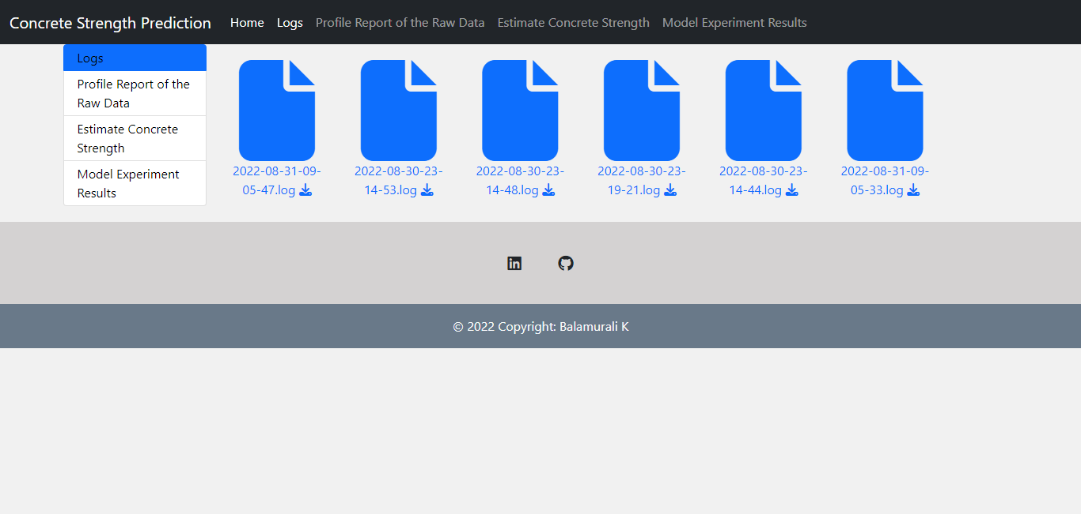

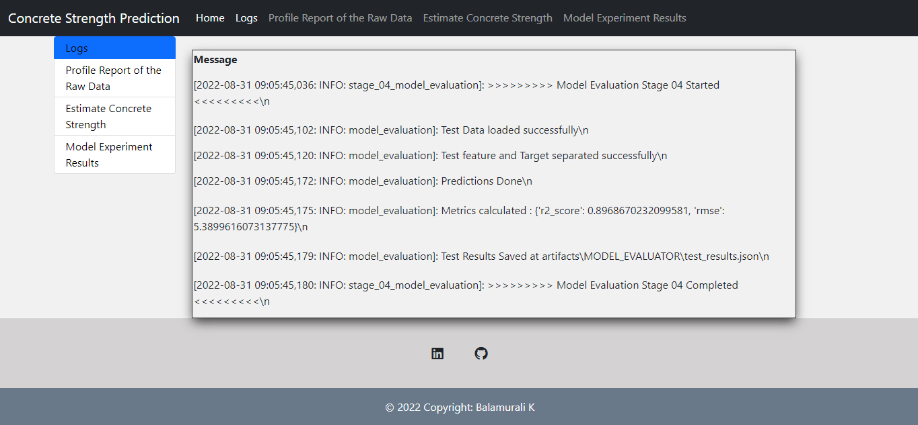

Model Experiment Results:

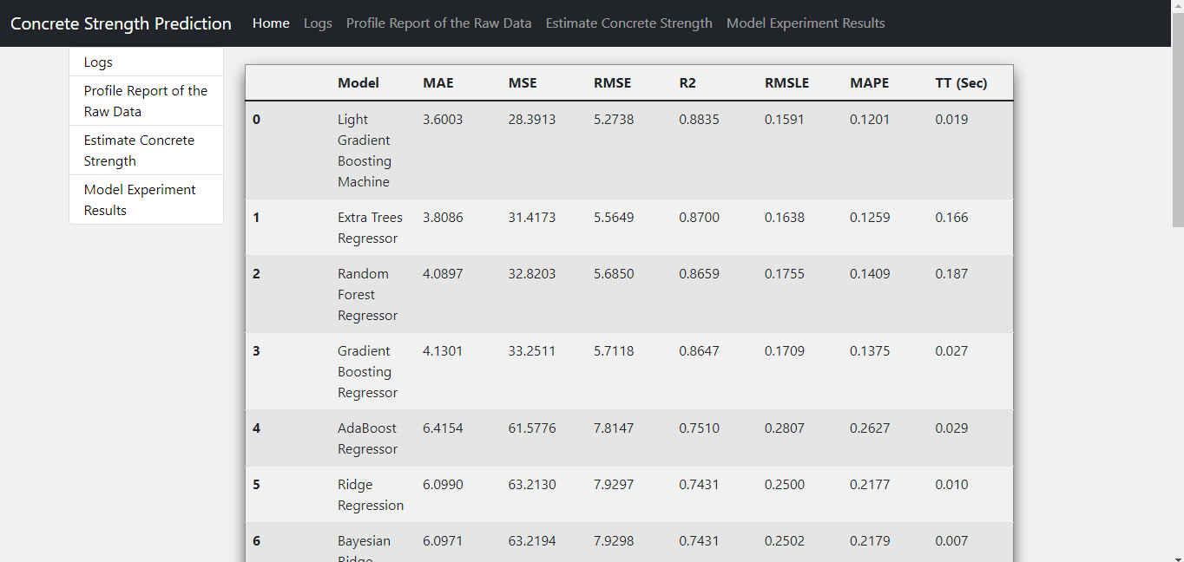

Profile Report of the Data:

